Is 2012 good for visitor numbers?
When London first one the right to stage the 2012 Summer Olympic and Paralympic Games, the city anticipated a major boost to sports tourism based revenue as a result. However, claims of failures to exploit these opportunities have recently been levelled at the Government.
Chief Executive of Travelodge, Grant Hearn, has accused the Government of ‘incredible apathy’ in the promotion of the London 2012 Games. Hearn believes too little is being done to fulfil promises to use the Olympics to boost tourism.
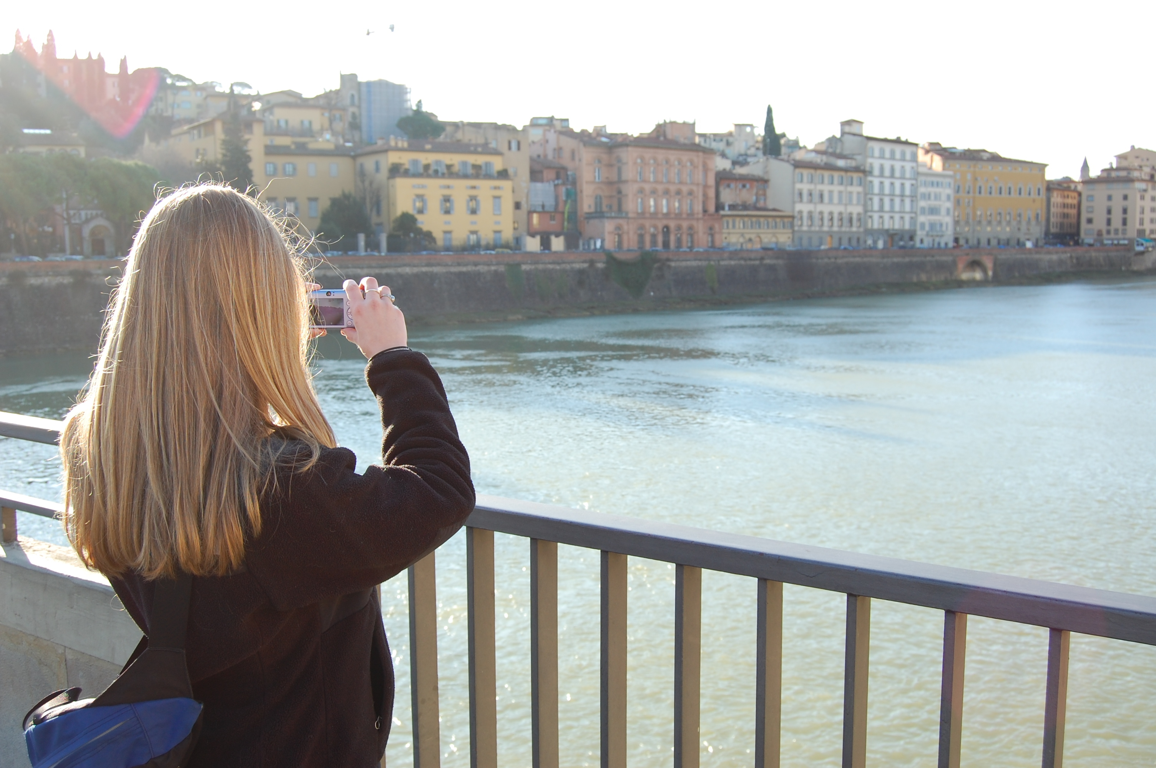
Image created by iantmcfarland and reproduced under a Creative Commons licence.

Hearns’ fears are based on an independent research study undertaken for Travelodge soon after the rights to stage the Games were awarded to London. The study found that whilst Olympic host countries achieved average tourism growth rates of 2.3% in the four years prior to the Games), tourism revenue for London has, worryingly, fallen continuously since Summer 2008.

But is Hearn being unfair? After all, the economic crisis of 2008, sparked by spiralling falls in the value of Credit Debt Obligations (essentially bundles of subprime mortgage debt) triggered a worldwide recession that affected virtually all industries. It could be argued that tourism sector was affected notably by the recession, and it would be understandable if the Government had subsequently cut back on some commitments as a result.

A Once in an Era Opportunity

Mr Hearn believes that Tony Blair's call for the 2012 Games to be a “once-in-an-era opportunity for British tourism” appears to have fallen on deaf ears: “With just two years to go we should be doing all we can to exploit the fact we are hosting the Games yet nothing appears to be happening...the Government is showing incredible apathy.”

It is perhaps concerning that Visit Britain, the UK’s central tourism agency, had its annual government funding cut by £9 million between 2007 and the 2010/11 financial year, and may be set to receive a further 20% cut in revenue. But again, the effects of the economic crisis that began in 2008 cannot be underestimated in terms of its contribution to this cut in funding.

Official figures similarly echo a fall in tourism revenue, with a 7% drop in the number of international visitors to Britain in the last three months of 2009. This represents the worst performance for London-based tourist revenue since 2004.

START THE DISCUSSION
- Do you think that Hearns’ fears are well founded?
- Do you feel that the Government has not met tourism commitments as much as it could, as a result of the economic crisis?
- What is the structure and role of Visit Britain and how is it funded?
- What can be done to ensure that London does not experience a reduction in visitor numbers after 2012 (as all host cities have done since 19888)?

FIND OUT MORE
Britain’s Official Travel & Tourism Guide
http://www.visitbritain.com/
VisitBritain Annual Report and Accounts for the year ended 31st March 2009
http://www.official-documents.gov.uk/document/hc0607/hc07/0751/0751.asp
VisitBritain Corporate Publication
http://www.visitbritain.org/aboutus/corporatepublications/index.aspx

CREDITS
© Oxford Brookes University 2010. oxb:060111:027dd

This resource was produced as part of the 2012 Learning Legacies Project managed by the HEA Hospitality, Leisure, Sport and Tourism Subject Centre at Oxford Brookes University and was released as an Open Educational Resource. The project was funded by HEFCE and part of the JISC/HE Academy UKOER programme. Except where otherwise noted above and below, this work is released under a Creative Commons Attribution only licence.

Exceptions to the Licence
The name of Oxford Brookes University and the Oxford Brookes University logo are the name and registered marks of Oxford Brookes University. To the fullest extent permitted by law Oxford Brookes University reserves all its rights in its name and marks, which may not be used except with its written permission.

The JISC logo is licensed under the terms of the Creative Commons Attribution-Non-Commercial-No Derivative Works 2.0 UK: England & Wales Licence. All reproductions must comply with the terms of that licence.

The Higher Education Academy logo and the HEA Hospitality, Leisure, Sport and Tourism Subject Centre logo are owned by the Higher Education Academy Limited and may be freely distributed and copied for educational purposes only, provided that appropriate acknowledgement is given to the Higher Education Academy as the copyright holder and original publisher.



Reusing this work
To refer to or reuse parts of this work please include the copyright notice above including the serial number. The only exception is if you intend to only reuse a part of the work with its own specific copyright notice, in which case cite that.

If you create a new piece of work based on the original (at least in part), it will help other users to find your work if you modify and reuse this serial number. When you reuse this work, edit the serial number by choosing 3 letters to start (your initials or institutional code are good examples), change the date section (between the colons) to your creation date in ddmmyy format and retain the last 5 digits from the original serial number. Make the new serial number your copyright declaration or add it to an existing one, e.g. ‘abc:101011:027dd’.

If you create a new piece of work or do not wish to link a new work with any existing materials contained within, a new code should be created. Choose your own 3-letter code, add the creation date and search as below on Google with a plus sign at the start, e.g. ‘+tom:030504’. If nothing comes back citing this code then add a new 5-letter code of your choice to the end, e.g.; ‘:01lex’, and do a final search for the whole code. If the search returns a positive result, make up a new 5-letter code and try again. Add the new code your copyright declaration or add it to an existing one.

